**Analytics and Covid-19**

**Assignment #1 - Guidance Document**

**Purpose**

The global Covid-19 pandemic has made the general public more aware than ever, of the value of data and analytics. Given the volatility, uncertainty and fluidity of the situation, it has also demonstrated how the absence of data, fundamental to decision-making, can result in significant poor understanding, bias, and in some cases illogical conclusions and actions. Recognizing these challenges, the pandemic also demonstrates the issues relating to data management and the quality/quantity trade off which such massive amounts of data being present, represents. The amount of data which we can collect in real-time is staggering, however, our ability to aggregate this data into meaningful value for decision-making purposes, requires the need for prioritization and definitive resource allocation decisions. This exercise is intended to have teams think of this prioritization process to not only respond to today’s challenges, but tomorrow’s as well.

**Covid-19 Overview**

As we are all painfully aware, the current Covid-19 pandemic has, and will continue to fundamentally change our lives. As of the date of this writing (April 26, 2020) just under 3 million cases of Covid-19, have been confirmed world-wide, with over 200,000 deaths (approximately 850,000+ have recovered). As with any iceberg visualization, the numbers identified above are simply felt to be the tip of the iceberg, with considerably more exposure concluded due to conciseness issues relating to the reporting accuracy of the identified current case load, along with non-reporting influencers such as asymptomatic carriers, mild virus contraction resulting in non-reporting of symptoms, deaths identified from factors which the virus has contributed to (pneumonia, etc.), and other external factors such as access to health care, health literacy, delay in diagnosis (testing), reliability of screening, etc.

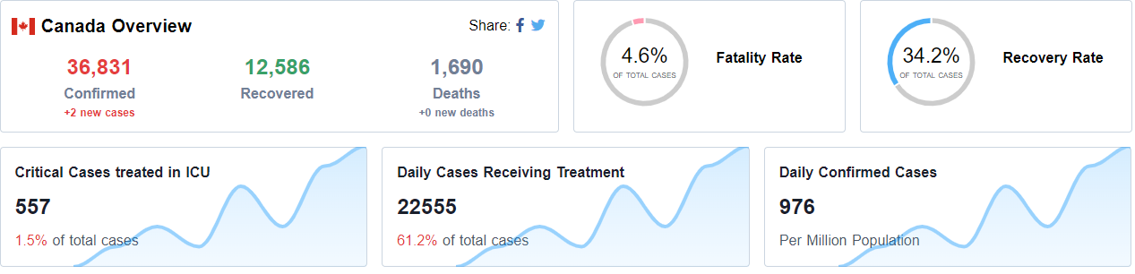

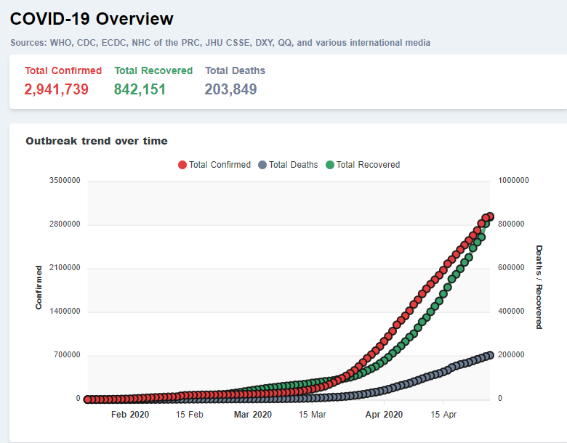

**Layering Economics On Top Of It**

In a time of just two months, the world’s economic activity has ground to a halt. Initial 2020 global GDP growth predictions had the global economy growing at a pace of 2.6%. Revised economic forecasts by the Conference Board of Canada now have global GDP growth of -3%, with the potential for global economic contraction. The United States, a critical driver of global economic activity, could see economic contraction by as much as 8.5% in 2020, with an overall GDP decline in Q2, 2020, exceeding 20%. These estimates are based on economic activity resuming in Q3 and Q4 of 2020. Europe, particularly hard-hit by the pandemic, coupled with a number of EU members heavily leveraged with relatively weak economies (i.e. Italy, Spain) will lag behind other global regions in its longer-term recovery. The EU, overall, expects GDP declines in excess of 7.5% in 2020, with some countries (Spain, Italy) facing significantly greater GDP contraction. China, with pre-pandemic GDP growth of 6.5%, will now see growth in the 2.5% to 3% range. Should a second wave of Covid-19 impact the reigniting of economic activity, then a further declination of GDP activity cannot be ruled out. At this stage, what is apparent with respect to overall global economic activity is the following:

* The service sector has absorbed the brunt of the overall economic damage, driven by a decline of approximately 30% in consumer spending, with significant volatility swings occurring across most major market sectors.
* The disruptions to the global marketplace which have occurred will, most likely, cause multi-national firms to rethink supply chain processes and protocols, and seek to significantly diversify product and component sourcing and manufacturing dependencies. Supply chain bottlenecks and disruptions are expected to continue through 2020.
* Aggressive monetary and fiscal stimulus initiatives undertaken by governments around the world could fuel fairly significant inflationary pressures going forward.
* Business sector investment confidence is extremely weak and investments within the energy market, driven by a collapse in oil prices, have almost completely disappeared.

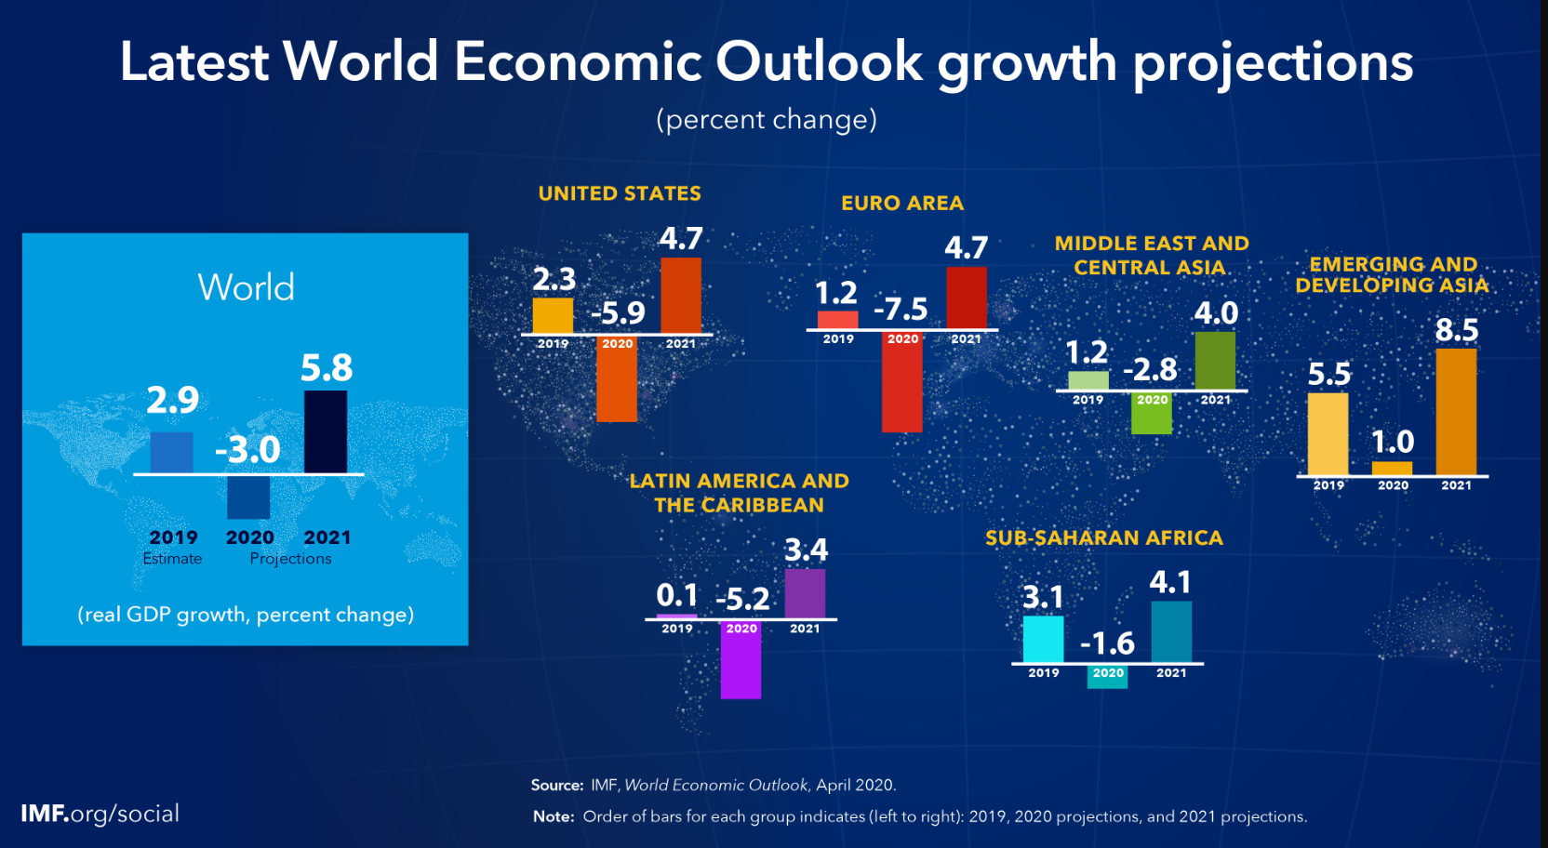

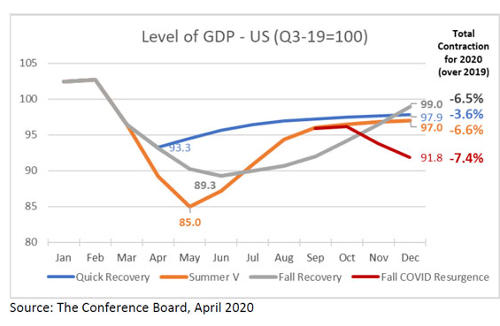

**Emergency Management**

An effective emergency response to catastrophic events requires an Emergency Response Plan (ERP) that mobilizes an alternate delivery framework of services quickly and efficiently, while fully integrating the use of all available public and private resources, and capabilities. Executed upon properly, the ERP is focused on providing a high level of activity-based and management control and the necessary accompanying communications, thereby ensuring the proper mixing and coordination of all response elements in a timely and efficient manner. In a perfect situation, the ERP would establish and communicate the arrangements and procedures necessary for a prompt and effective response to an emergency via the leveraging of an established pre-determined framework for the continuation of operations and service delivery. An Emergency Response Plan would also identify and develop the mechanisms and arrangements necessary not only for the recovery from an emergency, but also for the reduction and effective management and control of future risks.

In its completeness, emergency management consists of organized programs and activities put into place to deal with actual or potential emergencies or disasters. It is based on a risk management approach and includes the following five components:

* **Prevention** – this refers to the actions taken to prevent the emergency itself and can greatly diminish the response and recovery activities required for certain emergencies. It may result in a long-term, cost-effective reduction of risk. Prevention measures are broadly classified as either structural or non-structural and include capital improvements, technology investments, regulations, building codes and public education programs.
* **Mitigation** - refers to the actions taken to reduce or eliminate the effects of an emergency. It can also greatly diminish the response and recovery activities required for certain emergencies, thereby resulting in a long-term, cost-effective reduction of risk. Similar to prevention, mitigation measures are broadly classified as either structural or non-structural and include capital improvements, technology investments, regulations, building codes and public education programs.
* **Preparedness** - refers to those measures and/or activities taken prior to the emergency or disaster to ensure an effective response. Preparedness measures include plans, training, exercises, employee education, alerting and notification systems, procedures, organization, infrastructure protection, and standards.
* **Response** - refers to measures taken to respond to an emergency. The aim of these measures is to ensure that a focused, controlled, coordinated, and effective response is quickly undertaken at the outset of the emergency to minimize its impact on public safety. When an emergency occurs, the immediate initial focus of operations is on meeting the emergency needs of people, saving lives, and protecting property and the environment. This effort may last from a few hours to several days or longer, depending on the situation. As response activities begin to taper off, the operational focus begins to shift from response to recovery. The transition from response to recovery must be coordinated in a manner which ensures as smooth and as seamless a transition as is possible.
* **Recovery** - refers to those measures taken to recover from an emergency or disaster. The aim of these measures is to assist individuals, businesses and communities to return to a state of normalcy. Recovery measures include environmental clean-up, return of evacuees, emergency financial assistance, and critical incident stress counseling. Recovery activities usually begin almost as soon as the response begins and continue after the response activities cease.

**Key Features of an ERP**

Key features relating to the effectiveness of a coordinated response, include:

1. The coordination of a variety of levels of response players and activities which need to be communicated to, upon the awareness, threat, or onset of an emergency;
2. The integration, allocation, and coordination of additional external support (ex. Provincial) resources, which have been received and/or are in-route and have been directed to assist stakeholders;
3. The communication of the declared emergency and the notification of existing and incoming resources, to, and from, affected and unaffected stakeholders.
4. Acknowledgement of resource layering from both the provincial and federal governments, if requested or delivered, and the management coordination of the various agencies involved, particularly with respect to national and/or provincial emergency declarations.

An example of one key feature of an ERP could be the following:

We want to test our emergency (disaster) response plan. We have to push everybody out of the building and go remote in an hour. What needs to happen?

**Challenge – Option**

Your team has been charged with revisiting service delivery strategy and, on a secondary basis, the data collection goals of a particular component of the economic landscape. In responding to the challenge you are being asked to assess one of the following:

* A specific business entity (such as one of the companies which a team member works for),
* An industry sector (such as financial services, retail (Department Stores, Luxury players), Fitness Services, restaurant service, airline industry, cruise lines industry, commercial real estate, etc.),
* A government entity (national, provincial, municipal), or a specific health care entity (nursing home, hospital, etc.). You could also view this from a Human Resource perspective, if so desired.
* Alternate sector focus, approved by the instructor

Your challenge, more specifically, is to brief your audience on perceived potential core components of a business recovery plan. This analysis would focus on the perceived immediate-term and long-term structural market and therefore, strategy-required changes which the Covid-19 pandemic will cause (think factors and forces) in the particular chosen sector, or with the particular company chosen to assess. In this regard, the expectation is that you will provide specific recommendations of the initial focus which AI and analytics-based methodologies could be leveraged in a manner which improves the depth and breadth of response initiatives, given the current catastrophic event underway, as well as potential longer-term risk exposures anticipated or feared. Your analysis and recommendation should include at least five specific recommendations around which such a strategy could be built around.

In assessing this situation, a viable approach would be to review the situation, identify the critical complication which you would like to focus your analysis on and recommendations towards, define the key, critical questions which need to be responded to, and offer your recommendations for initial strategic assessment of potential resource allocation focus.

Sample questions to consider, in developing your response, could be (not limited to) some of the following:

1. Given what has and is occurring, what is the most profitable way to operate in the near-term?
2. What about the longer term? What underlying fundamentals have changed, thereby causing us to ask the question, how do we continue to serve our customers, going forward?
3. What key performance indicators do we need to focus on, given the changes which have occurred and are anticipated to occur? In other words, what do you need to know?
4. If the future of business will become more evidenced-based, where should we be focusing our resources in terms of defining the right path forward? Think in terms of the prioritization of data development efforts around your key performance indicators.
5. What are the critical data forces which we should be leveraging?
6. How can we be the constant in the lives of our stakeholders/businesses, when they are dealing with significant variables and uncertainties?

**Submission Structure**

* Consider this a presentation briefing by your team to the senior management team of the specific company identified, or Executive Committee of a market sector’s national or international association.
* Assume that you will have approximately 15 minutes to deliver your observations and conclusions.
* Your core (presentation) slide deck is limited to 8 slides, excluding your title page. You may have additional support slides, supplemental to the presentation, which offer additional information and validation. These will serve as an “appendix” to the formal presentation slides and be identified as “supplemental”.
* The use of mapping and/or time-pacing techniques, inflection analysis, or other course concepts, in support of your information delivery, is fully acceptable and encouraged. Similarly, heightened emphasis on AI and/or Analytics methodologies is recommended.
* Likewise, the use of broader resources associated with information searches relating to AI and analytics and the emergency-response market is highly recommended.

**Team Presentations**

Team presentations will take place, at a mutually convenient time for all parties, between May 23, 2020 and June 2, 2020.

Presentations will be evaluated by a team (2 to 3) of “judges”. Presentations are assessed on the basis of content (analysis, conclusions, and recommendations), as well as the effectiveness of the communication of the team’s findings. A copy of the presentation assessment rubric is attached as a separate file to the course website. The slide deck composition and content is also evaluated separately by the instructor, after which a final grade determination is made with respect to both deliverables.